**Note: For Code Optimization, We created HRV column in IBI table using temp table. It stores the HRV value for all the patient. we haven’t calculated HRV separately for the queries needed instead we used it from IBI table.**

**\*\*\*\*\*\*\*\*\*\*\*\*\*\*\*\*\*\*\*\*\*created the hrv column in IBI Table\*\*\*\*\*\*\*\*\*\*\*\*\***

**-- Create a temporary table to store HRV calculations**

CREATE TEMP TABLE Temp_HRV AS

SELECT

patientid,

datestamp,

rmssd_ms,

AVG(rmssd_ms) OVER (PARTITION BY patientid ORDER BY datestamp ASC) * 600 AS HRV

FROM

ibi;

**--altering the IBI table with adding HRV column**

ALTER TABLE IBI

ADD COLUMN HRV numeric;

**-- Update the IBI table with HRV values**

UPDATE ibi SET HRV = Temp_HRV.HRV

FROM Temp_HRV

WHERE

ibi.patientid = Temp_HRV.patientid

AND ibi.datestamp = Temp_HRV.datestamp;

**-- Drop the temporary table**

DROP TABLE Temp_HRV;

**-- selecting the table**

select patientid, AVG(rmssd_ms)*600 as hrv from ibi group by patientid

**\*\*\*\*\*\*\*\*\*\*\*\*\*\*\*\*\*\*\*\*\*\*\*\*\*\*\*\*\*\*\*\*\*\*\*\*\*\*\*\*\*\*\*\*\*\*\*\*\*\*\*\*\*\*\*\*\*\*\*\*\*\*\*\*\*\*\*\*\*\*\*\*\*\*\*\*\*\***

**@@@One Other Team Member created the HRV table Seaprately and she used this**

CREATE TABLE HRV AS

SELECT

patientid,

datestamp,

rmssd_ms,

AVG(rmssd_ms) OVER (PARTITION BY patientid ORDER BY datestamp ASC) * 600 AS HRV FROM ibi;

**Q1: Write a query to get a list of patients with event type of EGV and glucose (mgdl)**

**greater than 155 .**

**Query**

SELECT id, event_type, glucose_value_mgdl

FROM public.eventtype WHERE event_type = 'EGV' AND glucose_value_mgdl > 155;

**OUTPUT**

**Q2 :How many patients consumed meals with at least 20 grams of protein in it?**

**Query**

SELECT COUNT(DISTINCT patientid) as PatientCount

FROM foodlog

WHERE protein >= 20;

**OUTPUT**

**Q3 Who consumed maximum calories during dinner? (assuming the dinner time is after 6pm-8pm)**

**Query**

WITH total_dinner_calories as(

SELECT patientid,

sum(calorie) as total_dinner_calorie

FROM

foodlog

WHERE

EXTRACT(HOUR FROM datetime) >= 18 AND EXTRACT(HOUR FROM datetime) < 20

GROUP BY patientid

)

SELECT t.patientid,

t.total_dinner_calorie As Maximum_Dinner_Calorie

FROM total_dinner_calories t

WHERE t.total_dinner_calorie=(SELECT MAX(x.total_dinner_calorie) from total_dinner_calories x)

**OUTPUT**

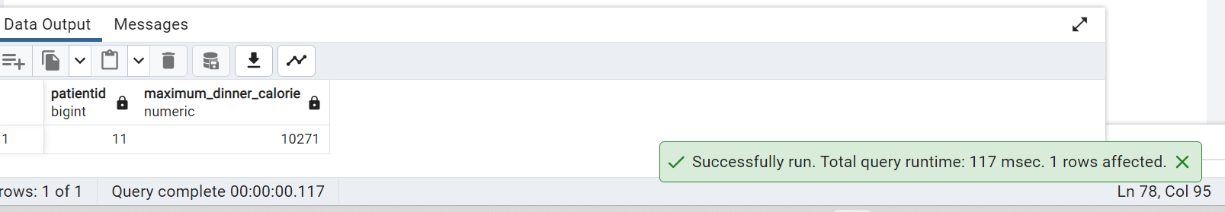

**Q4: Which patient showed a high level of stress on most days recorded for him/her?**

**Query**

WITH StressCounts AS ( SELECT

e.patientid,

COUNT(*) AS high_stress_days

FROM eda AS e WHERE

e.max_eda > 40

GROUP BY

e.patientid

)

SELECT s.patientid FROM StressCounts s

WHERE

s.high_stress_days = (

SELECT MAX(high_stress_days) FROM StressCounts

);

**OUTPUT**

**Q5: Based on mean HR and HRV alone, which patient would be considered least healthy?**

**Query**

SELECT i.patientid,

(AVG(h.max_hr) * AVG(i.hrv)) AS health_score

FROM ibi AS i

JOIN hr AS h ON i.patientid = h.patientid

GROUP BY i.patientid

ORDER BY health_score ASC

LIMIT 1;

**OUTPUT**

**Q6: Create a table that stores any Patient Demographics as firstname, dob,patientid,hba1c of your choice as the parent table.**

**Create a child table that contains max_EDA from EDA table and mean_HR from HR per patient and inherits all columns from the parent table**

**Query**

drop table patient_demographic cascade;

CREATE TABLE patient_demographic (

patientid serial PRIMARY KEY,

firstname VARCHAR(30) ,

dob DATE ,

hba1c DECIMAL(5, 2)

);

INSERT INTO patient_demographic (firstname, dob, hba1c)

VALUES ('Jane', '1990-01-01', 5.5);

select * from patient_demographic;

**OUTPUT**

drop table patient_additional_info cascade

CREATE TABLE patient_additional_info (

max_eda DECIMAL(5, 2),

mean_hr DECIMAL(5, 2),

patientid INT REFERENCES patient_demographic (patientid)

)INHERITS (patient_demographic);

INSERT INTO patient_additional_info(firstname, dob, hba1c,max_eda,mean_hr,patientid)

VALUES ('sita','1990-01-01',5.5,5.50,13.67,1);

select * from patient_additional_info ;

**OUTPUT**

**Q7: What percentage of the dataset is male vs what percentage is female?**

**Query**

SELECT gender,

COUNT(*) AS count,

Round((COUNT(*) * 100.0 / (SELECT COUNT(*) FROM demographics)),2) AS percentage

FROM demographics

GROUP BY gender;

**OUTPUT**

**Q8: Which patient has the highest max eda?**

**Query**

With Max_eda_score as

(SELECT patientid,

MAX(max_eda) AS highest_max_eda

FROM eda

GROUP BY patientid

)

SELECT m.patientid,

m.highest_max_eda

FROM Max_eda_score m

WHERE

m.highest_max_eda=(SELECT Max(x.highest_max_eda) from Max_eda_score x)

**OUTPUT**

**Q9: Display details of the prediabetic patients.**

**Query**

SELECT * FROM demographics WHERE hba1c >= 5.7 AND hba1c <= 6.4;

**OUTPUT**

**Q10: List the patients that fall into the highest EDA category by name, gender and age**

**Query**

SELECT

pd.firstname,

pd.lastname,

pd.gender,

pd.dob

FROM

demographics AS pd

INNER JOIN ( SELECT patientid, MAX(max_eda) AS highest_eda

FROM eda GROUP BY patientid

) AS max_eda_table ON pd.patientid = max_eda_table.patientid

WHERE max_eda_table.highest_eda = (SELECT MAX(max_eda) FROM eda);

**OUTPUT**

**Q11: How many patients have names starting with 'A'?**

**Query**

SELECT COUNT(*) as numberofpatients FROM demographics

WHERE firstname LIKE 'A%';

**OUTPUT**

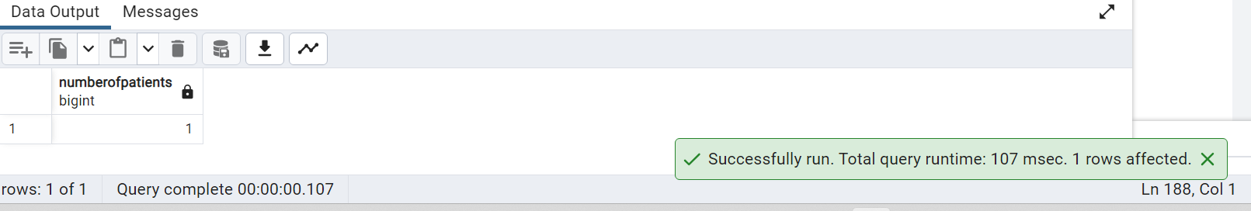

**Q12: Show the distribution of patients across age.**

**Query**

SELECT CASE WHEN dob IS NOT NULL THEN

EXTRACT(YEAR FROM AGE(NOW(), dob))

ELSE

NULL

END AS age,

COUNT(*) AS patient_count

FROM demographics GROUP BY age ORDER BY age;

**OUTPUT**

**Q13: Display the Date and Time in 2 seperate columns for the patient who consumed only Egg**

**Query**

SELECT

datetime AS consumption_datetime,

CAST(datetime AS DATE) AS consumption_date,

CAST(datetime AS TIME) AS consumption_time,

logged_food

FROM

foodlog

WHERE

logged_food = 'Egg';

**OUTPUT**

**Q14: Display list of patients along with the gender and hba1c for whom the glucose value is null.**

**Query**

SELECT

d.patientid,

d.gender,

d.hba1c

FROM demographics AS d

LEFT JOIN dexcom AS g ON d.patientid = g.patientid

WHERE g.glucose_value_mgdl IS NULL;

**OUTPUT**

**Q15: Rank patients in descending order of Max blood glucose value per day**

**Query**

WITH MaxGlucosePerDay AS (

SELECT

patientid,

DATE(datestamp) AS observation_date,

MAX(glucose_value_mgdl) AS max_daily_glucose

FROM dexcom

GROUP BY

patientid,

DATE(datestamp)

)

SELECT

patientid,

observation_date,

max_daily_glucose,

RANK() OVER (PARTITION BY observation_date ORDER BY max_daily_glucose DESC) AS rank_per_day

FROM MaxGlucosePerDay ORDER BY observation_date DESC, max_daily_glucose DESC;

**OUTPUT**

**Q16 : Assuming the IBI per patient is for every 10 milliseconds, calculate Patient-wise HRV from RMSSD.**

**/* to calculate HRV and create a column with HRV=Avg rmssd_ms from IBI per patientid from IBI * 600 */**

**Query**

-- Create a temporary table to store HRV calculations

CREATE TEMP TABLE Temp_HRV AS

SELECT

patientid,

datestamp,

rmssd_ms,

AVG(rmssd_ms) OVER (PARTITION BY patientid ORDER BY datestamp ASC) * 600 AS HRV FROM ibi;

ALTER TABLE IBI

ADD COLUMN HRV numeric;

-- Update the IBI table with HRV values

UPDATE ibi SET HRV = Temp_HRV.HRV

FROM Temp_HRV

WHERE

ibi.patientid = Temp_HRV.patientid

AND ibi.datestamp = Temp_HRV.datestamp;

-- Drop the temporary table

**OUTPUT:**

DROP TABLE Temp_HRV;

**Q.17 What is the % of total daily calories consumed by patient 14 after 3pm Vs Before 3pm?**

**Query:**

SELECT patientid,

SUM(CASE WHEN EXTRACT(hour FROM datetime) >= 15 THEN calorie ELSE 0 END) AS calories_after_3pm,

SUM(CASE WHEN EXTRACT(hour FROM datetime) < 15 THEN calorie ELSE 0 END) AS calories_before_3pm,

SUM(calorie) AS total_calories,

(SUM(CASE WHEN EXTRACT(hour FROM datetime) >= 15 THEN calorie ELSE 0 END) * 100.0) / SUM(calorie) AS percentage_after_3pm,

(SUM(CASE WHEN EXTRACT(hour FROM datetime) < 15 THEN calorie ELSE 0 END) * 100.0) / SUM(calorie) AS percentage_before_3pm

FROM foodlog

WHERE patientid = 14

GROUP BY

patientid;

**OUTPUT**

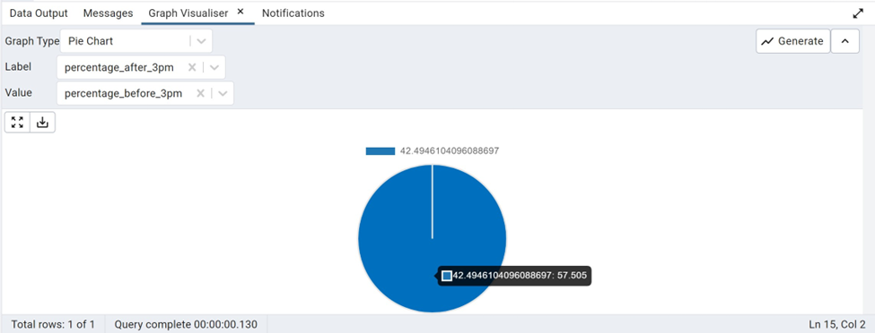

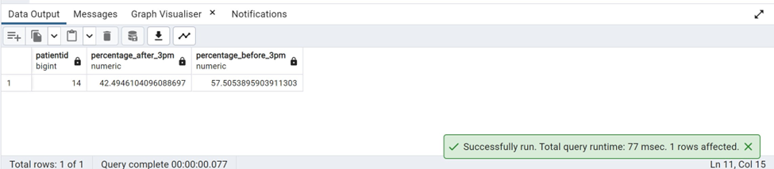

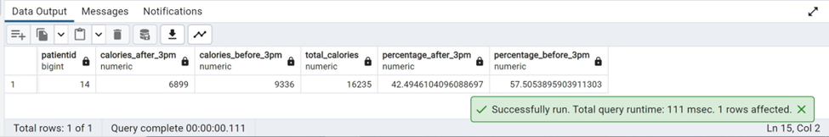

**Q18 Display 5 random patients with HbA1c less than 6.**

**Query:**

SELECT CONCAT(firstname,' ',lastname)

AS patient_name FROM demographics

WHERE hba1c < 6

ORDER BY RANDOM() LIMIT 5;

**OUTPUT**

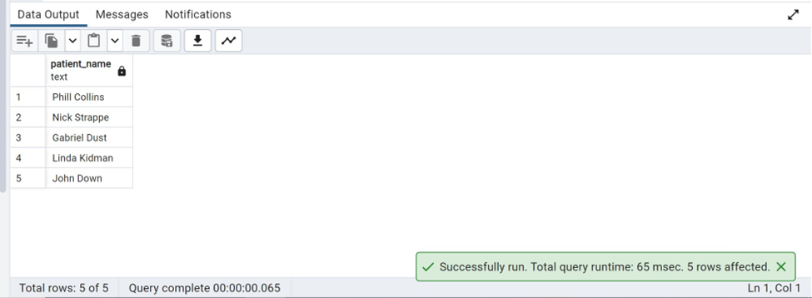

**Q19 Generate a random series of data using any column from any table as the base.**

**Query:**

SELECT calorie AS base_column, RANDOM() AS random_value

FROM foodlog;

**OUTPUT**

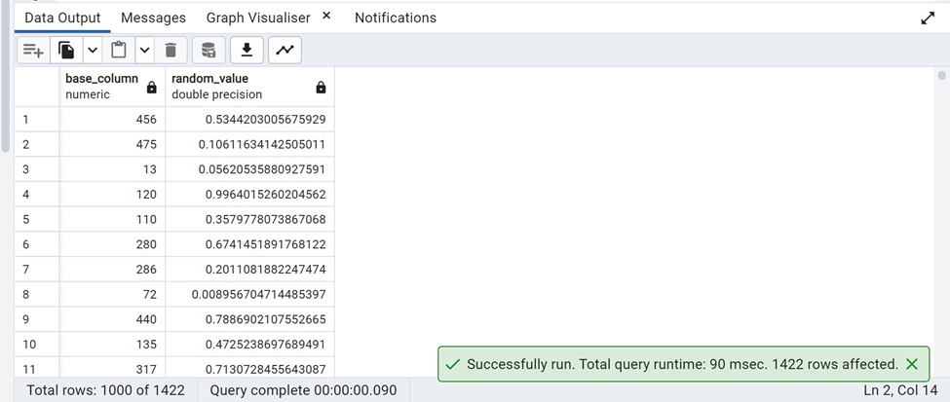

**Q20 Display the foods consumed by the youngest patient.**

**Query:**

SELECT f.logged_food FROM foodlog f

INNER JOIN (SELECT patientid FROM demographics

ORDER BY dob ASC

LIMIT 1) AS d

ON f.patientid =d.patientid;

**OUTPUT**

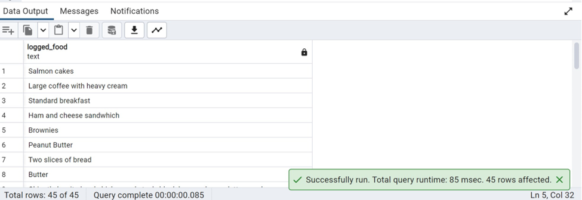

**Q21 Identify the patients that has letter ‘h’ in their first name and print the last letter of their first name.**

**Query:**

SELECT firstname, RIGHT(firstname,1) AS lastletter

FROM demographics

WHERE firstname LIKE '%h%';

**OUTPUT**

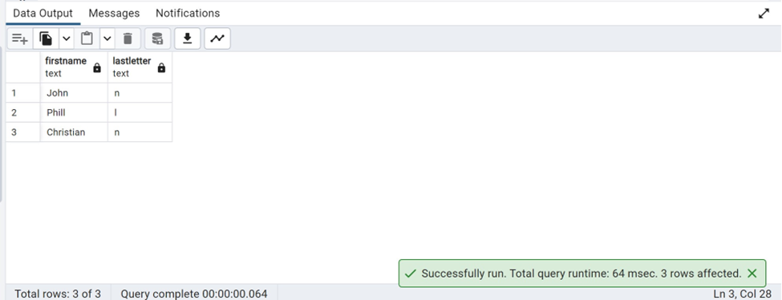

**Q22 Calculate the time spent by each patient outside the recommended blood glucose range.**

**Query:**

SELECT patientid,EXTRACT(EPOCH FROM (MAX(datestamp) - MIN(datestamp)))/3600 AS time_outside_range

FROM dexcom

WHERE

(glucose_value_mgdl < 70 OR glucose_value_mgdl >= 126)

GROUP BY patientid

ORDER BY patientid;

**OUTPUT**

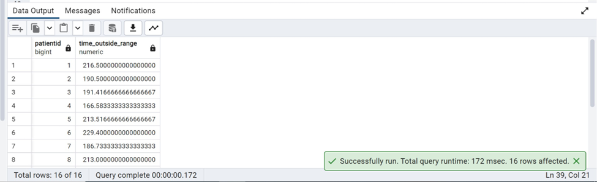

**Q23 Show the time in minutes recorded by the Dexcom for every patient.**

**Query:**

SELECT patientid, EXTRACT(EPOCH FROM datestamp::TIME)/60 AS time

FROM dexcom;

**OUTPUT**

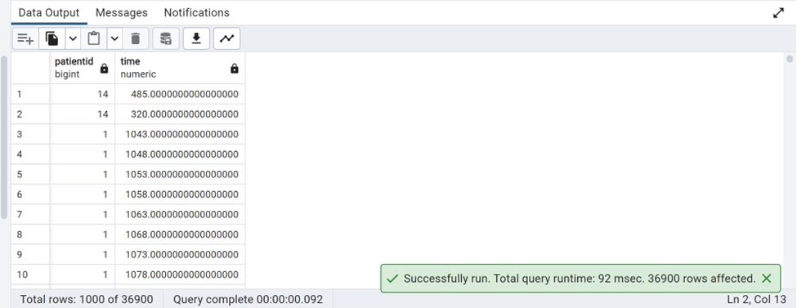

**Q24 List all the food eaten by patient Phill Collins.**

**Query:**

SELECT f.logged_food FROM foodlog f

INNER JOIN (SELECT patientid ,CONCAT(firstname,' ',lastname) AS patient_name FROM demographics) AS d

ON f.patientid = d.patientid

WHERE d.patient_name= 'Phill Collins';

**OUTPUT**

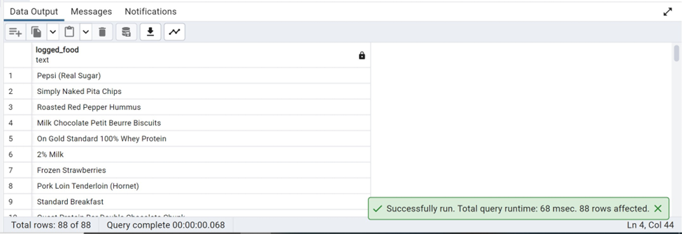

**Q25 Create a stored procedure to delete the min_EDA column in the table EDA.**

**Query:**

CREATE PROCEDURE delete_column()

LANGUAGE plpgsql

AS $$

BEGIN

EXECUTE 'ALTER TABLE eda DROP COLUMN min_EDA';

EXCEPTION

WHEN others THEN

RAISE NOTICE 'Column min_EDA does not exist in table EDA';

END;

$$

**OUTPUT**

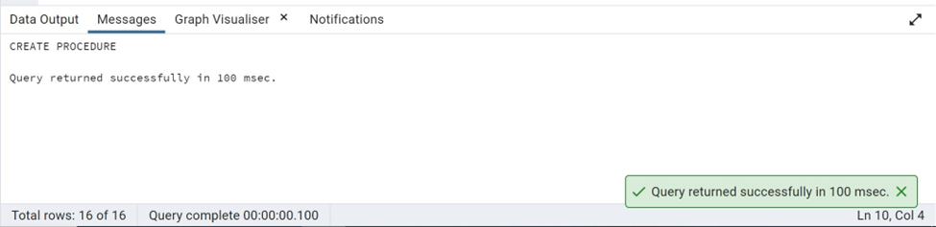

CALL delete_column();

**OUTPUT**

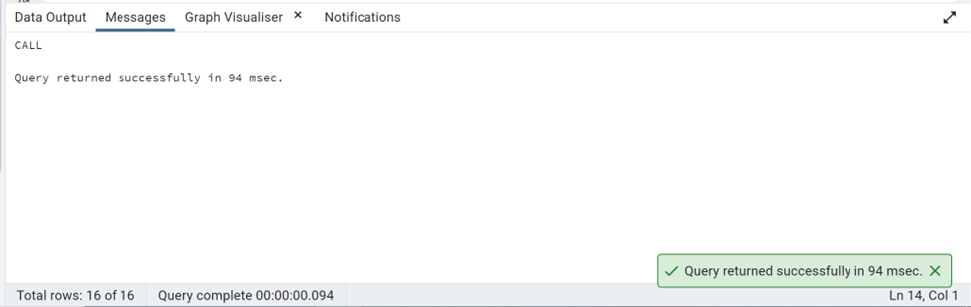

SELECT * FROM eda;

**OUTPUT**

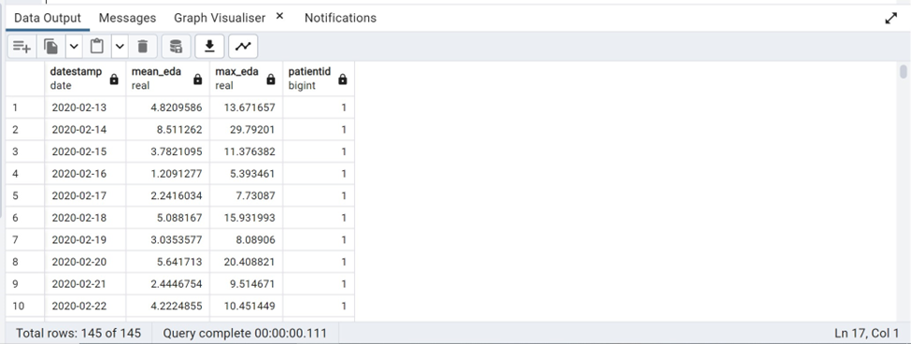

**Q26 When is the most common time of day for people to consume spinach?**

**Query:**

SELECT datetime::TIME AS time,

COUNT(*) AS repeatingNO

FROM foodlog

WHERE logged_food = 'Spinach'

GROUP BY time

ORDER BY repeatingNo DESC

LIMIT 1;

**OUTPUT**

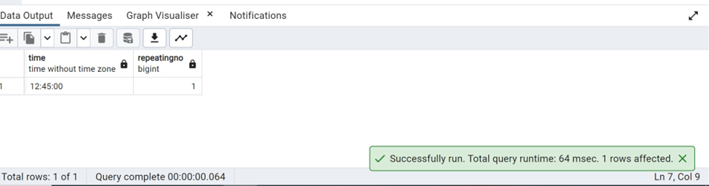

**Q27 Classify each patient based on their HRV range as high, low, or normal.**

**Query:**

SELECT patientid,(AVG(rmssd_ms)*600) AS hrv,

CASE

WHEN (AVG(rmssd_ms) * 600) < 20 THEN 'Low'

WHEN (AVG(rmssd_ms) * 600) >= 20 AND (AVG(rmssd_ms) * 600) <=30 THEN 'Normal'

ELSE 'High'

END

FROM ibi

GROUP BY patientid

ORDER BY patientid;

**OUTPUT**

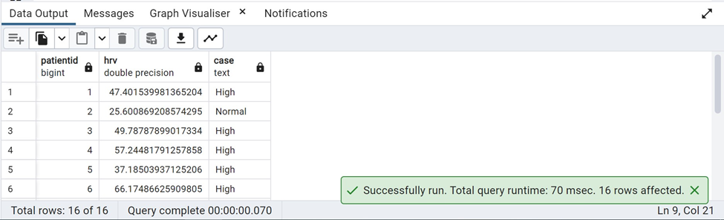

**Q28 List full name of all patients with ‘an’ in their first or last names.**

**Query:**

SELECT CONCAT(firstname,' ',lastname) AS fullname FROM demographics

WHERE firstname LIKE '%an%' OR lastname LIKE '%an%';

**OUTPUT**

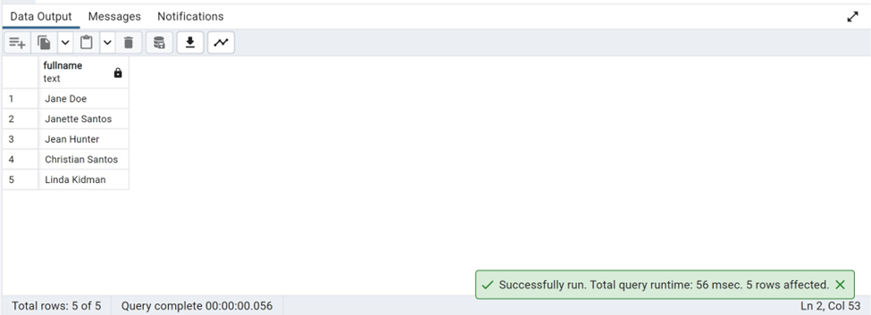

**Q29 Display a pie chart of gender vs average HbA1c.**

**Query:**

SELECT gender, AVG(HbA1c)

FROM demographics

GROUP BY gender;

**OUTPUT**

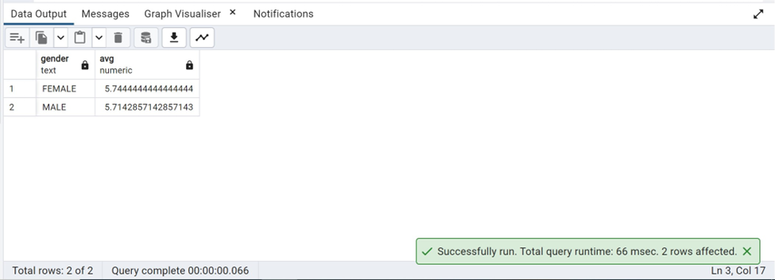

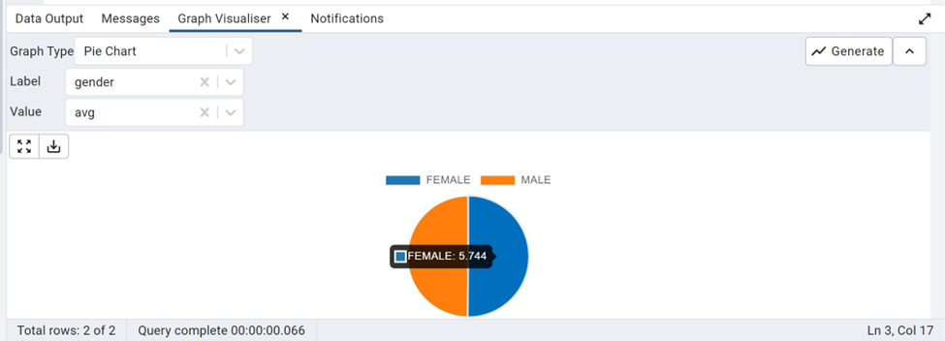

**Q30 The recommended daily allowance of fiber is approximately 25 grams a day. What % of this does every patient get on average?**

**Query:**

SELECT patientid,

AVG(dietary_fiber) AS avg_fiber,

(AVG(dietary_fiber)/25)*100 AS percentage_fiber

FROM foodlog

GROUP BY patientid

ORDER BY patientid;

**OUTPUT**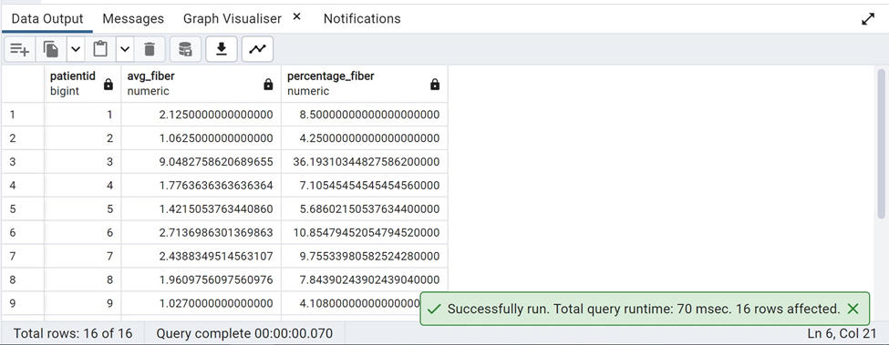

**Q31 What is the relationship between EDA and Mean HR?**

**Query:**

SELECT corr(e.mean_eda, t2.mean_hr)

FROM eda e

JOIN hr t2

ON e.patientid = t2.patientid;

**OUTPUT**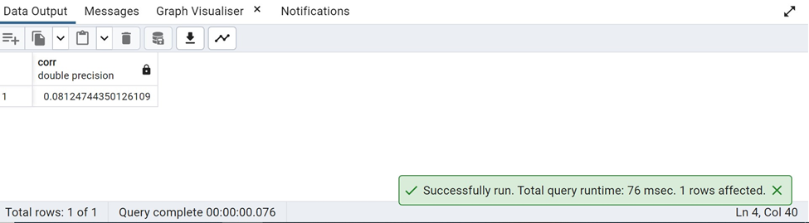

**Q32 Show the patient that spent the maximum time out of range.**

**Query:**

SELECT patientid,EXTRACT(EPOCH FROM (MAX(datestamp) - MIN(datestamp)))/3600 AS time_outside_range

FROM dexcom

WHERE

(glucose_value_mgdl < 70 OR glucose_value_mgdl >= 126)

GROUP BY patientid

ORDER BY patientid

LIMIT 1;

**OUTPUT**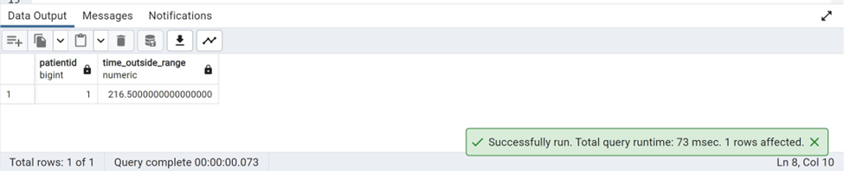

**Q33 : Create a User Defined function that returns min glucose value and patient ID for any date entered**

**Query**

DROP FUNCTION if exists minGlucose;

DROP TABLE if exists min_glucose_dexcom;

CREATE TABLE min_glucose_dexcom

( glucose_value_mgdl real,

patientid integer);

CREATE FUNCTION minGlucose(dts date) RETURNS min_glucose_dexcom AS $$

DELETE FROM min_glucose_dexcom;

INSERT INTO min_glucose_dexcom

SELECT MIN(glucose_value_mgdl),

patientid FROM dexcom

WHERE date(datestamp) = dts and glucose_value_mgdl is not null

GROUP BY patientid;

SELECT glucose_value_mgdl,

patientid

FROM min_glucose_dexcom;

$$ LANGUAGE SQL

;

-- Call the above procedure to display the patientid and minimum glucose value for a date.

SELECT * FROM minGlucose ('2020-02-16');

**Output**

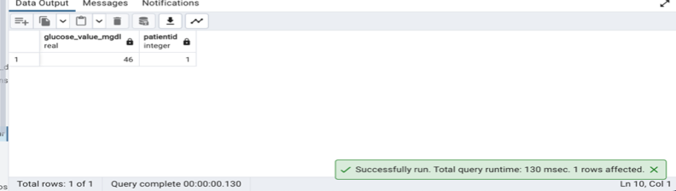

**Q34 : Write a query to find the day of highest mean HR value for each patient and display it along with the patient id.**

**Query**

SELECT datestamp,

hr.patientid,

mean_hr

FROM hr,

(SELECT MAX(mean_hr) AS mean_hr2 ,

patientid from hr

GROUP BY patientid) hr2

WHERE hr.patientid = hr2.patientid

AND hr.mean_hr = hr2.mean_hr2

;

**Output**

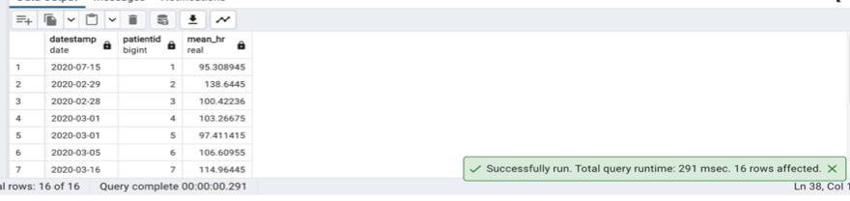

**Q35: Create view to store Patient ID, Date, Avg Glucose value and Patient Day to every patient, ranging from 1-11 based on every patients minimum date and maximum date (eg: Day1,Day2 for each patient)**

**Query**

CREATE OR REPLACE VIEW patient_glucose_daily_summary AS

SELECT

patientid,

'Day ' || ROW_NUMBER() OVER (PARTITION BY patientid ORDER BY reading_date) AS patient_day,

date(reading_date) as reading_date,

avg_glucose

FROM (

select

patientid,

date_trunc('day',datestamp) as reading_date,

avg(glucose_value_mgdl) as avg_glucose

from dexcom

group by

patientid,

reading_date

order by patientid, reading_date asc) subquery;

SELECT * FROM patient_glucose_daily_summary;

**Output**

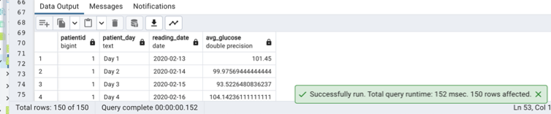

**Q36 : Using width bucket functions, group patients into 4 HRV categories**

**Query**

SELECT

distinct

CASE

WHEN bucket = 1 THEN '1. Low HRV'

WHEN bucket = 2 THEN '2. Moderate HRV'

WHEN bucket = 3 THEN '3. Moderately High HRV'

WHEN bucket = 4 THEN '4. High HRV'

ELSE 'Invalid HRV'

END AS hrv_bucket,

patientid,

hrv

FROM (

select patientid,

hrv,

width_bucket(hrv, (select min(hrv) from hrv),(select max(hrv) from hrv),3) as bucket

from hrv

) AS hrv_bucketed

order by 1,3

;

**Output**

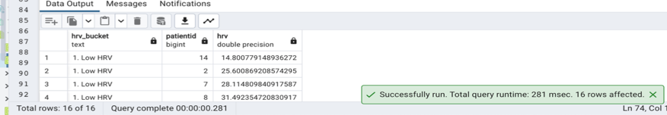

**Q37 : Is there a correlation between High EDA and HRV. If so, display this data by querying the relevant tables?**

**Query**

WITH HighEda AS (

SELECT

e.patientid,

e.datestamp AS eda_timestamp,

e.max_eda as high_eda,

h.datestamp AS hrv_timestamp,

h.hrv

FROM eda e

JOIN hrv h ON e.patientid = h.patientid

WHERE e.max_eda > 40

)

SELECT

CORR(HighEda.high_eda, HighEda.hrv) AS correlation

FROM HighEda;

**Output**

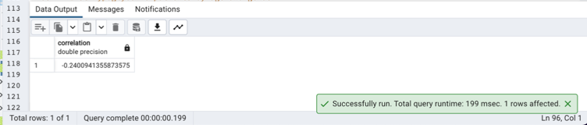

**Q38 : List hypoglycemic patients by age and gender**

**Query**

SELECT

d.patientid,

d.gender,

date_part('year', age(current_date, d.dob)) AS age,

dx.glucose_value_mgdl

FROM demographics d

JOIN dexcom dx ON d.patientid = dx.patientid

WHERE dx.glucose_value_mgdl < 70

ORDER BY age, gender;

**Output**

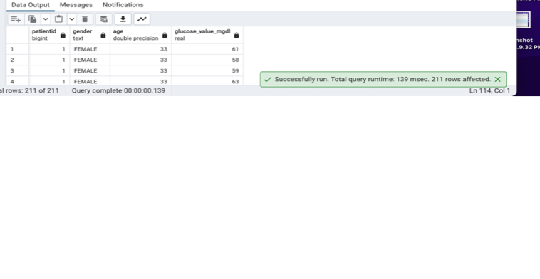

**Q39 : Write a query using recursive view(use the given dataset only)**

**Query**

CREATE OR REPLACE RECURSIVE VIEW max_mean_hr (datestamp, patientid, mean_hr) AS

WITH RECURSIVE recursive_cte AS (

SELECT

DATE(datestamp) AS datestamp,

patientid,

mean_hr

FROM hr

WHERE mean_hr > 100

UNION ALL

SELECT

DATE(hr2.datestamp) AS datestamp,

hr2.patientid,

hr2.mean_hr

FROM hr hr2

INNER JOIN recursive_cte r ON hr2.patientid = r.patientid

WHERE hr2.mean_hr > 100

)

SELECT * FROM recursive_cte;

select * from max_mean_hr limit 10;

**Output**

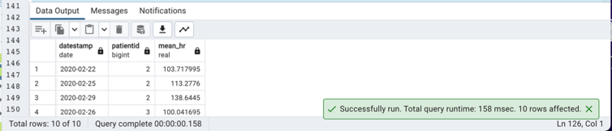

**Q40 : Create a stored procedure that adds a column to table IBI. The column should just be the date part extracted from IBI.Date**

**Query**

-- DROP Column if exists

ALTER TABLE IBI

drop column if exists date_part;

-- Create procedure

CREATE OR REPLACE PROCEDURE add_ibi_date()

LANGUAGE plpgsql

AS $$

BEGIN

-- Add the new column 'date_part' to the 'IBI' table

ALTER TABLE IBI ADD COLUMN date_part date;

-- Update the 'date_part' column with the date part from 'Date'

UPDATE IBI SET date_part = DATE(datestamp);

END;

$$;

CALL add_ibi_date();

select * from ibi;

**Output**

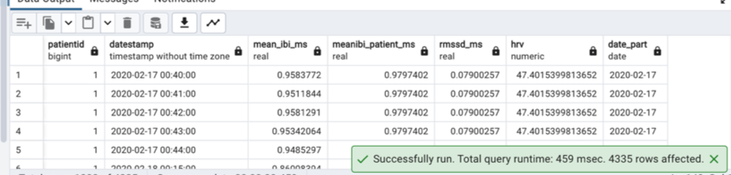

**Q 41 : Fetch the list of Patient ID's whose sugar consumption exceeded 30 grams on a meal from FoodLog table.**

**Query**

SELECT DISTINCT patientid, MAX(sugar) as max_sugar

FROM foodlog

WHERE sugar > 30

GROUP BY foodlog.patientid

ORDER BY patientid ASC;

**Output**

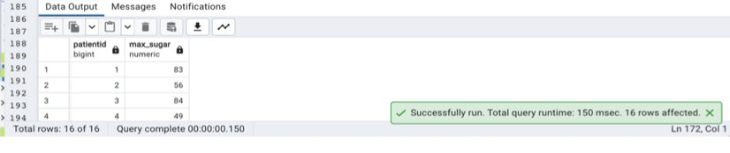

**Q42 : How many patients are celebrating their birthday this month?**

**Query**

SELECT COUNT(patientid)

FROM demographics

WHERE

EXTRACT(MONTH FROM demographics.DOB)= EXTRACT(MONTH FROM current_date);

**Output**

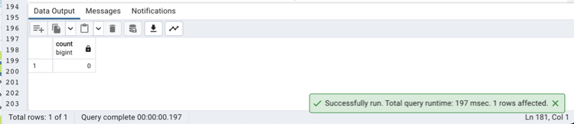

**Q43 : How many different types of events were recorded in the Dexcom tables? Display counts against each Event type**

**Query**

SELECT et.event_type, COUNT(*) AS event_count

FROM dexcom AS d

JOIN eventtype AS et ON d.eventid = et.id

GROUP BY et.event_type;

**Output**

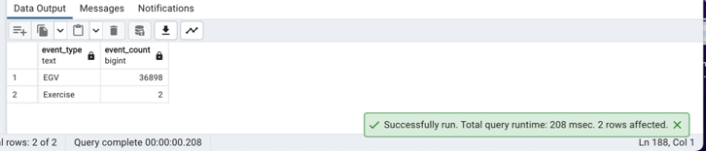

**Q44 : How many prediabetic/diabetic patients also had a high level of stress?**

**Query**

select count(diabetics.patientid)

from

(select patientid,

hba1c,

case when hba1c >= 6.5 then 'diabetic'

when hba1c > 5.7 and hba1c < 6.5 then 'prediabetic'

else 'normal' end

as diabetic_level

from demographics) diabetics,

(select patientid

-- ,max_eda

from eda

where max_eda > 40

union

select patientid

-- ,hrv

from hrv

where hrv < 20

union

select patientid

-- ,mean_hr

from hr

where mean_hr > 100

order by patientid) high_stress

where high_stress.patientid = diabetics.patientid

and diabetics.diabetic_level in ('prediabetic','diabetic');

**Output**

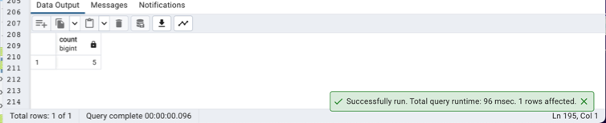

**Q45 : List the food that coincided with the time of highest blood sugar for every patient.**

**Query**

WITH HighSugarFood AS (

SELECT

patientid,

logged_food,

ROW_NUMBER() OVER (PARTITION BY PatientID ORDER BY sugar DESC) AS RowNum

FROM

foodlog

)

SELECT

patientid,

logged_food

FROM

HighSugarFood

WHERE

RowNum = 1;

**Output**

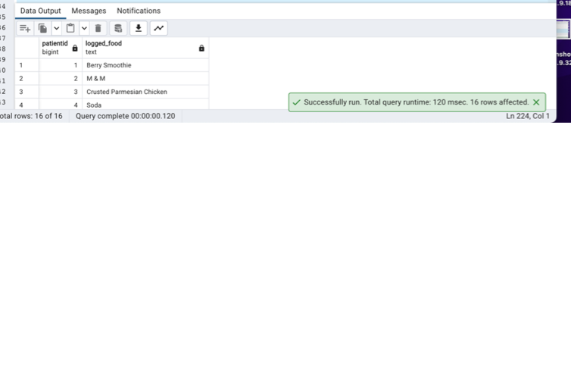**Q46 : How many patients have first names with length >7 letters?**

**Query**

SELECT COUNT(*) AS long_names

FROM demographics

WHERE LENGTH(firstname) > 7;

**Output**

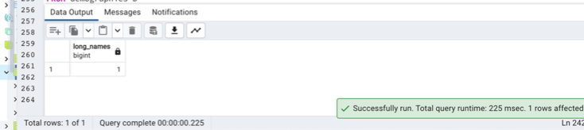

**Q47 : List all foods logged that end with 'se'. Ensure that the output is in Title Case.**

**Query**

SELECT INITCAP(logged_food)

FROM foodlog

WHERE logged_food LIKE '%se';

**Output**

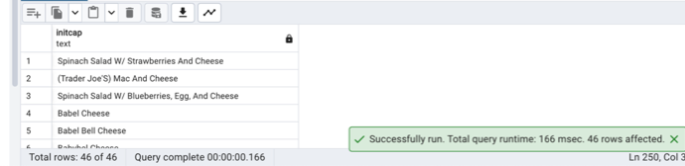

**Q48 List the patients who had a birthday the same week as their glucose or IBI readings.**

**Query**

SELECT DISTINCT D.patientid, D.DOB

FROM demographics D

INNER JOIN

dexcom Dx ON D.PatientID = Dx.PatientID AND EXTRACT(WEEK FROM D.DOB) = EXTRACT(WEEK FROM Dx.datestamp)

UNION

SELECT DISTINCT D.patientid, D.DOB

FROM demographics D

INNER JOIN

ibi I ON D.PatientID = I.PatientID AND EXTRACT(WEEK FROM D.DOB) = EXTRACT(WEEK FROM I.datestamp);

**Output**

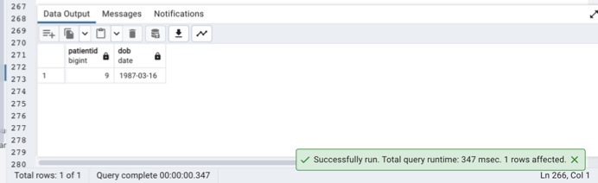

**Q 49: Assuming breakfast is between 8 am and 11 am. How many patients ate a meal with bananas in it?**

**Query:**

SELECT count( distinct patientid) as total_patients from foodlog

where Extract(hour from datetime)

between 8 and 11 and logged_food = 'Banana'

**OUTPUT**

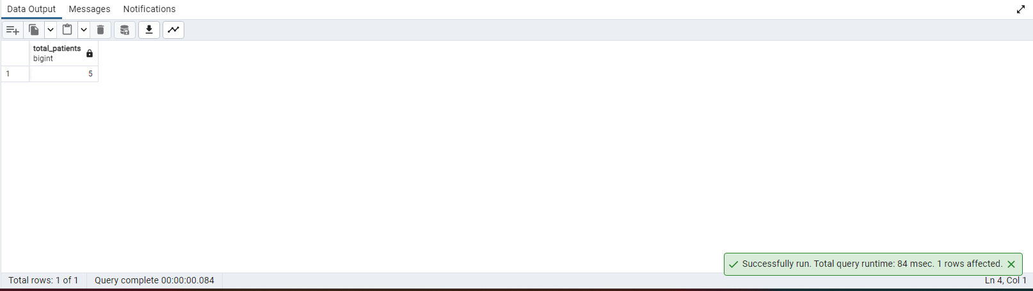

**Q 50: Create a User defined function that returns the age of any patient based on input**

**Query**

create or replace function get_age(inputid bigint)

returns int

language plpgsql

as

$$

declare

age int;

begin

select DATE_PART('YEAR', age(current_date, dob))

into age

from demographics

where patientid=inputid;

return age;

end;

$$

select get_age(1)

**OUTPUT**

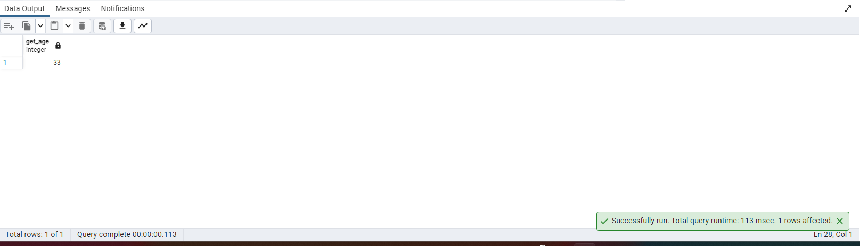

**Q 51:Based on Number of hyper and hypoglycemic incidents per patient, which patient has the least control over their blood sugar**

**Query**

select concat(firstname,' ',lastname),demographics.patientid,count( demographics.patientid )

from dexcom, demographics where dexcom.glucose_value_mgdl<70 or dexcom.glucose_value_mgdl>=126

group by demographics.patientid order by count(demographics.patientid) desc limit 1

**OUTPUT**

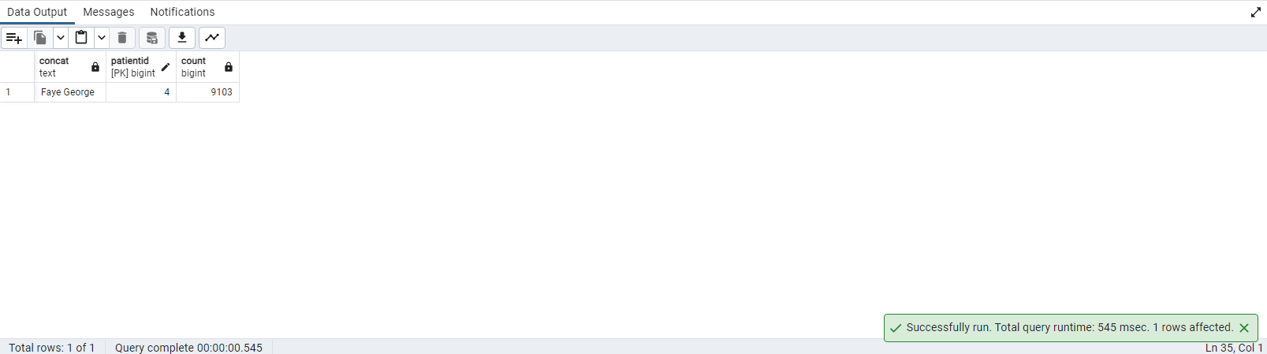

**Q 52: Display patients details with event details and minimum heart rate**

**Query**

select concat(firstname,' ',lastname),demographics.patientid,eventtype.event_type,

eventtype.event_subtype,eventtype.glucose_value_mgdl,eventtype.id,hr.min_hr

from demographics inner join dexcom on demographics.patientid= dexcom.patientid

inner join eventtype on dexcom.eventid= eventtype.id inner join hr on dexcom.patientid=hr.patientid

order by hr.min_hr asc limit 1

**OUTPUT**

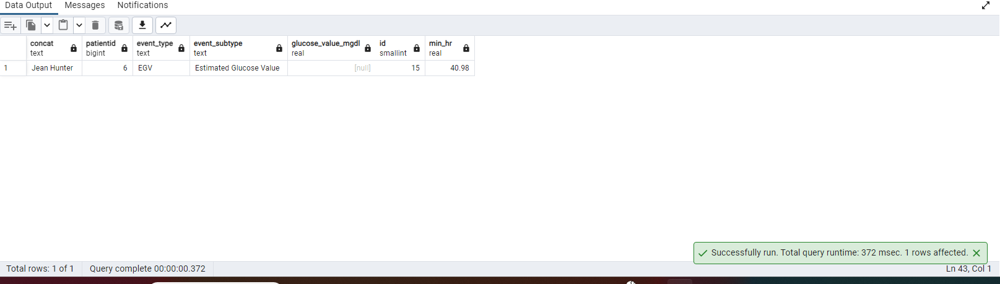

**Q 53: Display a list of patients whose daily max_eda lies between 40 and 50**

**Query**

select concat(firstname,' ',lastname),demographics.patientid, eda.max_eda from demographics

inner join eda on demographics.patientid = eda.patientid where eda.max_eda between 40 and 50

**OUTPUT**

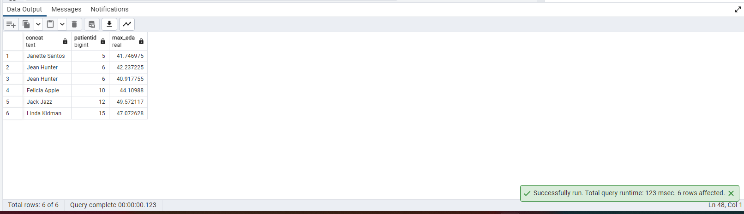

**Q 54:Count the number of hyper and hypoglycemic incidents per patient**

**Query**

select patientid, count(glucose_value_mgdl) from dexcom where glucose_value_mgdl<70 or glucose_value_mgdl>=126

group by patientid

**OUTPUT**

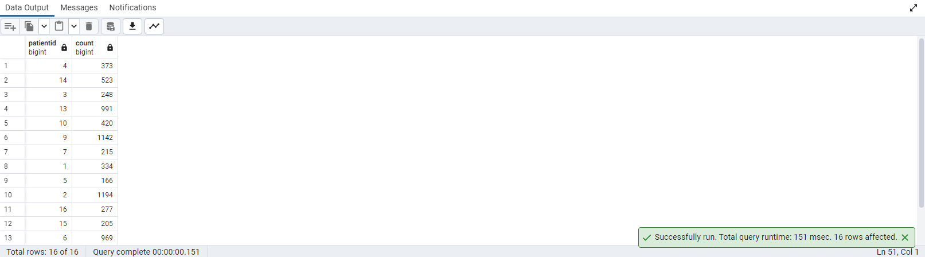

**Q 55: What is the variance from mean for all patients for the table IBI?**

**Query**

select variance(mean_ibi_ms) from ibi

**OUTPUT**

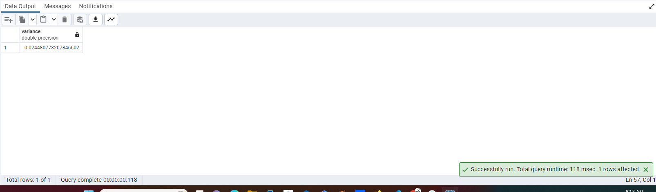

**Q 56:Create a view that combines all relevant patient demographics and lab markers into one. Call this view ‘Patient_Overview’**

**Query**

create or replace view Patient_Overview as select concat(firstname,' ',lastname),

demographics.patientid, demographics.gender , dexcom.glucose_value_mgdl,

eda.mean_eda,

hr.mean_hr

from demographics, dexcom, eda, hr

where

dexcom.patientid = demographics.patientid

and eda.patientid =demographics.patientid

and hr.patientid = demographics.patientid

select * from Patient_Overview

**OUTPUT**

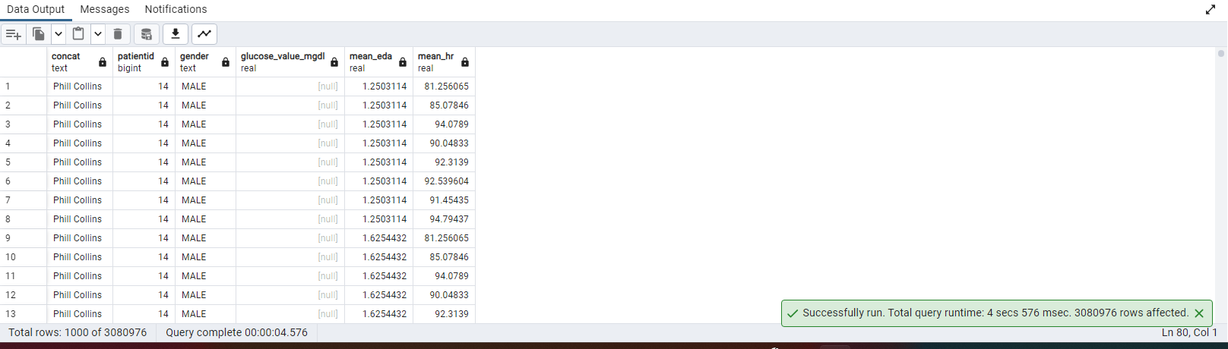

**Q 57:Create a table that stores an array of biomarkers: Min(Glucose Value), Avg(Mean_HR), Max(Max_EDA) for every patient. The result should look like this: (Link in next cell)**

**Query**

create table newtable(

pid int,

biomarkers numeric []

)

insert into newtable

select dexcom.patientid,array[ min(dexcom.glucose_value_mgdl),avg(hr.mean_hr),max(eda.max_eda)]

from dexcom inner join hr on dexcom.patientid = hr.patientid inner join eda on hr.patientid=eda.patientid

group by dexcom.patientid

select * from newtable order by pid

drop table newtable

**OUTPUT**

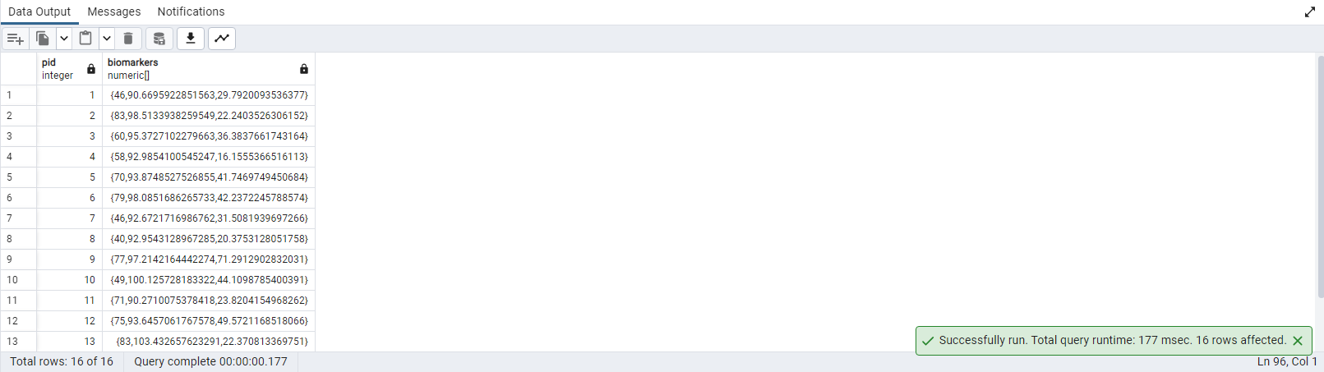

**Q 58:Assuming lunch is between 12pm and 2pm. Calculate the total number of calories consumed by each patient for lunch on "2020-02-24"**

**Query**

select patientid, sum(calorie) as total_calorie from foodlog

where

((Extract(hour from datetime) between 12 and 14) and cast(datetime as date) = '2020-02-24')

group by patientid

**OUTPUT**

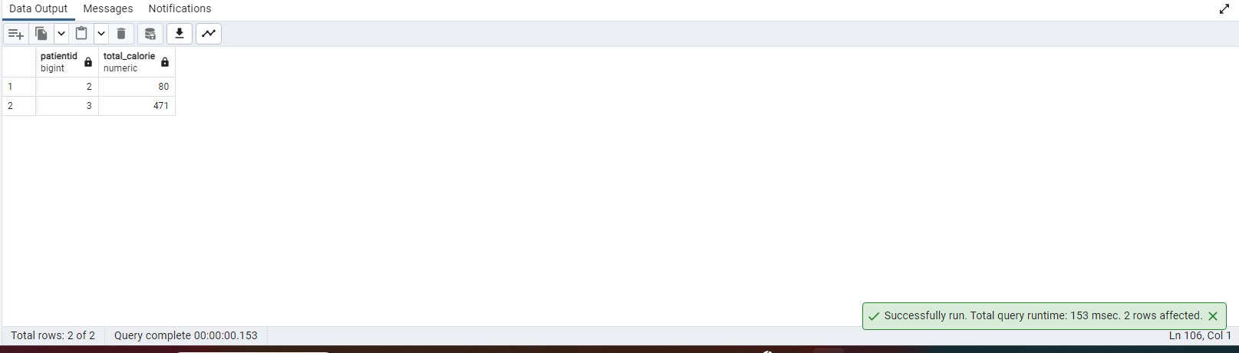

**Q 59:What is the total length of time recorded for each patient(in hours) in the Dexcom table?**

**Query**

SELECT

patientid,

EXTRACT(EPOCH FROM (MAX(datestamp) - MIN(datestamp))) / 3600 AS time_in_hours

FROM dexcom

GROUP BY patientid

ORDER BY patientid ASC;

**OUTPUT**

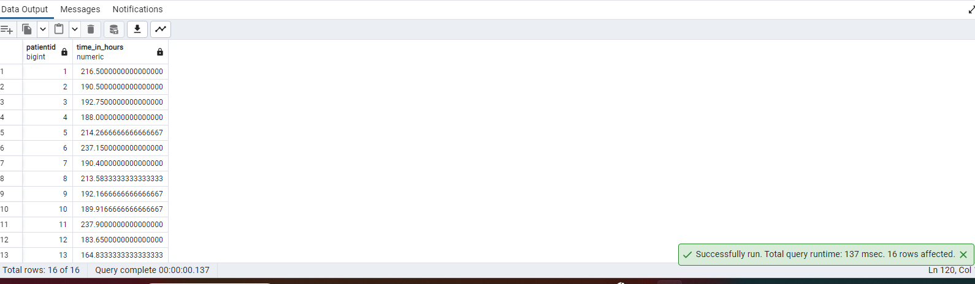

**Q 60:Display the first, last name, patient age and max glucose reading in one string for every patient**

**Query**

select demographics.patientid, demographics.firstname||' '||demographics.lastname||' '||

DATE_PART('YEAR', age(current_date, dob))||' '||max(glucose_value_mgdl) as details

from demographics, dexcom

group by demographics.patientid

**OUTPUT**

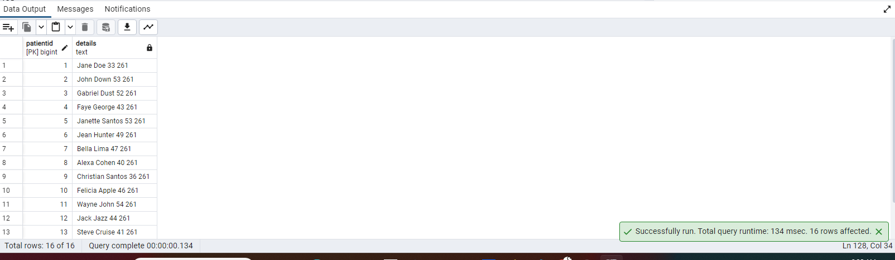

**Q 61:What is the average age of all patients in the database?**

**Query**

select avg(DATE_PART('YEAR', age(current_date, dob)))

from demographics

**OUTPUT**

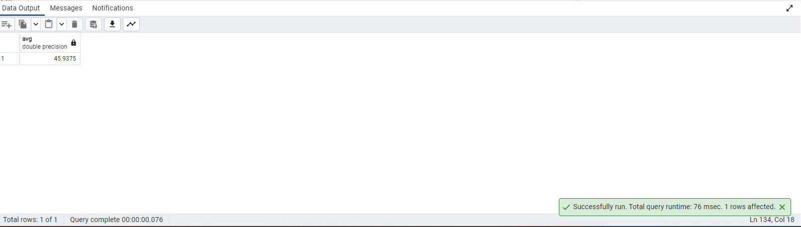

**Q 62:Display All female patients with age less than 50?**

**Query**

select * from demographics

where gender= 'FEMALE' and DATE_PART('YEAR', age(current_date, dob))< 50

**OUTPUT**

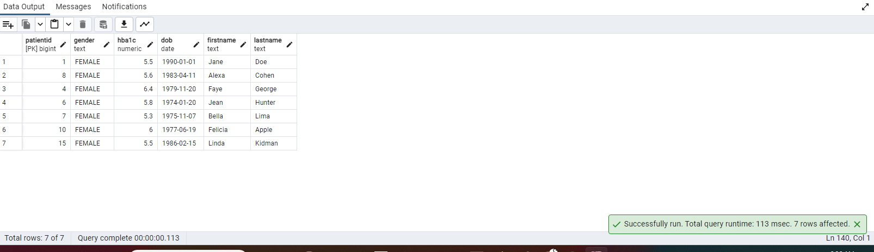

**Q 63:Display count of Event ID, Event Subtype and the first letter of the event subtype. Display all events**

Query

select eventtype.id,count(eventtype.id), eventtype.event_subtype, left(eventtype.event_subtype,1) as firstletter

from eventtype inner join dexcom on eventtype.id=dexcom.eventid group by eventtype.id

**OUTPUT**

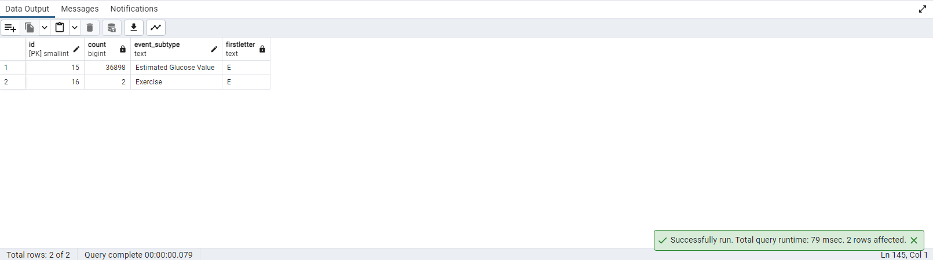

**Q 64:List the foods consumed by the patient(s) whose eventype is "Estimated Glucose Value**

**Query**

with cte as(

SELECT

dexcom.patientid, eventtype.event_subtype as eventtype

FROM

dexcom

INNER JOIN eventtype ON dexcom.eventid = eventtype.id

WHERE

eventtype.event_subtype = 'Estimated Glucose Value')

SELECT

distinct foodlog.patientid,

foodlog.logged_food,

cte.eventtype

FROM

foodlog, cte

WHERE

foodlog.patientid = cte.patientid

order by patientid asc

**OUTPUT**

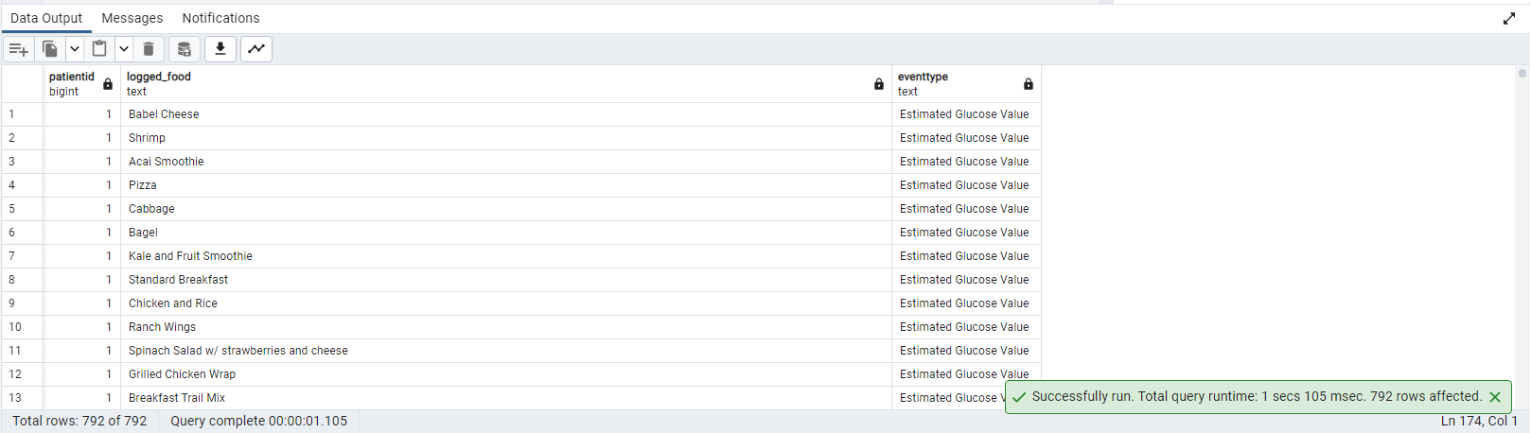

**Q65: Rank the patients' health based on HRV score and Control of blood sugar(AKA min time spent out of range)**

**Query:**

WITH HRV_Scores AS (

SELECT

patientid,

ROUND(hrv::numeric, 2) AS hrv_score

FROM ibi

GROUP BY patientid,hrv

),

Blood_Sugar_Control AS (

SELECT

d.patientid,

SUM(CASE

WHEN glucose_value_mgdl <55 OR glucose_value_mgdl >200 THEN 1

ELSE 0

END) AS time_out_of_range

FROM demographics d

JOIN dexcom g ON d.patientid = g.patientid

GROUP BY d.patientid

)

SELECT

d.patientid,

CONCAT(d.firstname, ' ', d.lastname) AS patients_full_name,

COALESCE(h.hrv_score, 0) AS hrv_score,

COALESCE(b.time_out_of_range, 0) AS time_out_of_range,

(COALESCE(h.hrv_score, 0) + COALESCE(b.time_out_of_range, 0)) AS combined_score,

CASE

WHEN (COALESCE(h.hrv_score, 0) + COALESCE(b.time_out_of_range, 0)) > 50 THEN 'poor health'

ELSE 'better health'

END AS health_status,

ROW_NUMBER() OVER (ORDER BY (COALESCE(h.hrv_score, 0) + COALESCE(b.time_out_of_range, 0)) ASC) AS health_rank

FROM demographics d

LEFT JOIN HRV_Scores h ON d.patientid = h.patientid

LEFT JOIN Blood_Sugar_Control b ON d.patientid = b.patientid

ORDER BY combined_score,patientid ;

**OUTPUT:**

**Q66. Create a trigger on the food log table that warns a person about any food logged that has more than 20 grams of sugar. The user should not be stopped from inserting the row. Only a warning is needed**

**Query:**

**Trigger function:**

CREATE OR REPLACE FUNCTION check_sugar_content()

RETURNS TRIGGER AS $$

BEGIN

IF NEW.sugar > 20 THEN

RAISE NOTICE 'Warning: High sugar content([%]) detected in the logged food ', NEW.sugar;

END IF;

RETURN NEW;

END;

$$ LANGUAGE plpgsql;

**OUTPUT:**

**Trigger :**

CREATE OR REPLACE TRIGGER foodlog_sugar_check

BEFORE INSERT ON foodlog

FOR EACH ROW

EXECUTE FUNCTION check_sugar_content();

**OUTPUT**:

**-- trying to insert a record with less sugar content should trigger the trigger function**

insert into foodlog(datetime,logged_food,calorie, total_carb, dietary_fiber, sugar,protein,total_fat,patientid) values(CURRENT_TIMESTAMP,'Berry juice',456,90,2,45,23,3,1)

**OUTPUT**:

**Q67.Display all the patients with high heart rate and prediabetic Query:**

SELECT

d.patientid,

d.gender,

d.hba1c ,

case

when d.hba1c <5.7 then 'normal'

when d.hba1c >5.7 and d.hba1c<6.4 then 'prediabetic'

when d.hba1c>6.4 then 'diabetic'

else 'invalid range'

end range,

h.mean_hr AS heart_rate

FROM

demographics d

JOIN

hr h ON d.patientid = h.patientid

WHERE

h.mean_hr > 100

AND

d.hba1c BETWEEN 5.7 AND 6.4; -- prediabetic range is between 5.7% and 6.4% as mentioned ----in data definition

**OUTPUT:**

**Q68. Display patients information who have tachycardia HR and a glucose value greater than 200. Query:**

SELECT

d.patientid,

d.gender,

h.mean_hr as tachycardia_HR,

glucose_value_mgdl as glucose_level

FROM

demographics d

JOIN

hr h ON d.patientid=h.patientid

JOIN

dexcom dx ON dx.patientid=d.patientid

WHERE

h.mean_hr>100 and dx.glucose_value_mgdl >200;

**OUTPUT:**

**Q69. Calculate the number of hypoglycemic incident per patient per day where glucose drops under 55 Query:**

SELECT

d.patientid,

DATE(dx.datestamp) AS day,

SUM(CASE WHEN dx.glucose_value_mgdl < 55 THEN 1 ELSE 0 END) AS hypoglycemic_incidents

FROM

demographics d

JOIN

dexcom as dx ON d.patientid = dx.patientid

GROUP BY

d.patientid, DATE(dx.datestamp)

HAVING

SUM(CASE WHEN dx.glucose_value_mgdl < 55 THEN 1 ELSE 0 END) > 0

ORDER BY

d.patientid, day;

**OUTPUT:**

**Q70. List the day wise calories intake for each patient.**

**Query:**

WITH UniqueDates AS (

SELECT DISTINCT patientid, datetime::DATE AS unique_date,

sum(calorie)::NUMERIC AS cal

FROM foodlog

group by patientid, unique_date

order by patientid

)

SELECT

f.patientid,

ud.unique_date,

'Day' || ROW_NUMBER() OVER (PARTITION BY ud.patientid ORDER BY ud.unique_date) AS patient_day,

ud.cal AS total_calories

FROM

uniquedates ud

JOIN

foodlog f ON f.patientid = ud.patientid

GROUP BY

f.patientid,ud.unique_date,ud.patientid,ud.cal

ORDER BY

f.patientid;

**OUTPUT**:

**Q71. Display the demographic details for the patient that had the maximum time below recommended blood glucose range**

**Query:**

WITH time_below_range AS (

SELECT

patientid,

SUM(CASE WHEN glucose_value_mgdl<60 THEN 1 ELSE 0 END) AS count_below_range -- count(patientid) AS time_below_range

FROM

dexcom

GROUP BY

patientid

)

SELECT

d.patientid,

d.gender,

d.hba1c,

d.dob

FROM

time_below_range tbr

JOIN

demographics d ON tbr.patientid = d.patientid

WHERE

tbr.count_below_range = (SELECT MAX(count_below_range) FROM time_below_range);

**OUTPUT:**

**Q72. How many patients have a minimum HR below the medically recommended level? Query:**

SELECT count(*) as minimum_hr_patient_count

FROM

hr h

JOIN

demographics d ON d.patientid=h.patientid

WHERE

h.min_hr <60

ORDER BY

minimum_hr_patient_count asc

**OUTPUT:**

**Q73. Create a trigger to raise notice and prevent the deletion of a record from ‘Patient_Overview’ .**

**Create View:**

CREATE or replace VIEW Patient_Overview AS

SELECT

d.patientid,

concat (d.firstname,' ',d.lastname),

d.gender,

d.hba1c,

d.dob,

ROUND(CAST(h.mean_hr AS NUMERIC), 2) AS average_heart_rate,

coalesce(g.glucose_value_mgdl,0) AS last_glucose_reading

FROM demographics d

LEFT JOIN hr h ON d.patientid = h.patientid

LEFT JOIN dexcom g ON d.patientid = g.patientid

**Trigger Function:**

-- Create an INSTEAD OF DELETE trigger on the 'demographics' table

CREATE OR REPLACE FUNCTION prevent_patient_overview_deletion() RETURNS TRIGGER AS $$

BEGIN

RAISE NOTICE 'Deletion from the "Patient_Overview" view is not allowed. Delete records from the underlying tables.';

RETURN NULL;

END;

$$ LANGUAGE plpgsql;

**OUTPUT:**

**Trigger**

-- Create the INSTEAD OF DELETE trigger

CREATE or REPLACE TRIGGER prevent_patient_overview_delete_trigger

INSTEAD OF DELETE ON Patient_Overview

FOR EACH ROW

EXECUTE FUNCTION prevent_patient_overview_deletion();

**OUTPUT:**

**Delete Event:**

delete from patient_overview where patientid=2

**OUTPUT:**

**Q74. What is the average heart rate, age and gender of the every patient in the dataset?**

**Query**:

SELECT

d.patientid,

d.gender,

date_part('year',age(d.dob)) as patient_age,

-- EXTRACT(year FROM age(current_date,d.dob)) :: int as age-- other way to extract age

round(cast(AVG(h.mean_hr) as NUMERIC), 2) AS patient_average_heart_rate

FROM

demographics d

JOIN

hr h ON d.patientid = h.patientid

GROUP BY

d.patientid, d.gender,patient_age

ORDER BY

d.patientid;

**OUTPUT:**

**Q75. What is the daily total calories consumed by every patient?**

**Query**

WITH UniqueDates AS (

SELECT DISTINCT patientid, datetime::DATE AS unique_date,

sum(calorie)::NUMERIC AS cal

FROM foodlog

group by patientid, unique_date

order by patientid

)

SELECT

f.patientid,

ud.unique_date,

'Day' || ROW_NUMBER() OVER (PARTITION BY ud.patientid ORDER BY ud.unique_date) AS patient_day,

ud.cal ||' '||'calories' AS total_calories

FROM

uniquedates ud

JOIN

foodlog f ON f.patientid = ud.patientid

GROUP BY

f.patientid,ud.unique_date,ud.patientid,ud.cal

ORDER BY

f.patientid;

**OUTPUT:**

**Q76. Write a query to classify max EDA into 5 categories and display the number of patients in each category.**

**Query**:

-- Category Table for EDA

WITH EDA_Category AS (

SELECT eda.patientid, eda.max_eda,

CASE

WHEN eda.max_eda <= 10 THEN 'Low'

WHEN eda.max_eda > 10 AND eda.max_eda <= 20 THEN 'Moderate'

WHEN eda.max_eda > 20 AND eda.max_eda <= 30 THEN 'High'

WHEN eda.max_eda > 30 AND eda.max_eda <= 40 THEN 'Very High'

ELSE 'Extreme'

END AS EDAcategory

FROM eda

)

-- Number of patients in each category display

SELECT EDAcategory, COUNT(patientid) AS number_of_patients

FROM EDA_Category

GROUP BY EDAcategory

ORDER BY EDAcategory;

**output:**

**Q77.List the daily max HR for patient with event type Exercise.**

**Query:**

SELECT

h.patientid,

e.event_type,

h.datestamp AS date,

MAX(h.max_hr) AS daily_max_hr

FROM

hr h

JOIN

demographics d ON h.patientid = d.patientid

JOIN

dexcom dx ON dx.patientid=d.patientid

JOIN

eventtype e ON e.id=dx.eventid

WHERE

e.event_type = 'Exercise'

GROUP BY

h.patientid, e.event_type, h.datestamp

ORDER BY

h.patientid, h.datestamp;

**OUTPUT:**

**Q78.What is the standard deviation from mean for all patients for the table HR?**

**Query:**

SELECT STDDEV(mean_hr) AS standard_deviation

FROM hr h

**OUTPUT:**

**Q79.Give the demographic details of the patient with event type ID of 16.**

**Query**:

SELECT d.patientid, d.gender, d.hba1c, d.dob, d.firstname, d.lastname

FROM demographics d

JOIN dexcom dx ON d.patientid = dx.patientid

JOIN eventtype e ON dx.eventid = e.id

WHERE e.id = 16;

**OUTPUT:**

**Q80.Display list of patients along with their gender having a tachycardia mean HR.**

**Query**

SELECT d.patientid,d.firstname, d.lastname,d.gender, h.mean_hr as heartrate_greaterthen100

FROM demographics d

JOIN hr h ON d.patientid=h.patientid

WHERE h.mean_hr>100 and h.mean_hr<250

**OUTPUT:**

